**Luganodes Project Development**

**Name: Kiran Manikandhan**

**Reg No: 20BCE1786**

**VIT Chennai**

**Introduction:**

The Cosmos Hub, a proof-of-stake blockchain, is powered by its native ATOM cryptocurrency. [Cosmos](https://www.kraken.com/prices/cosmos) aims to create a network of crypto networks united by open-source tools for streamlining transactions between them. Customizability and Interoperability sets Cosmos apart from other projects.

Cosmos aims to foster an ecosystem of networks that can share data and tokens programmatically, with no central party facilitating the activity rather than prioritizing its own network.

Setting up a node in Cosmos:

1. Installing tools and Go language in a Linux-based virtual machine.

* Installed Go version: 1.20.3.
* ‘Make’ command for compiling different sub-programs and building a final executable.

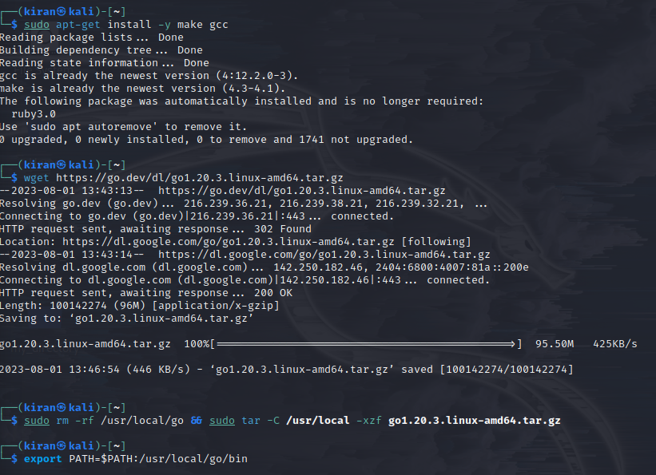

1. Installation and Configuration:
2. Build gaiad binary and initialize chain home folder.

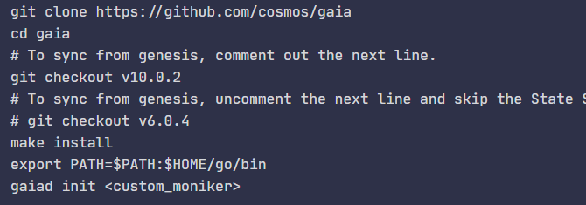

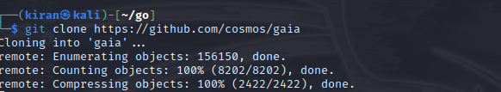

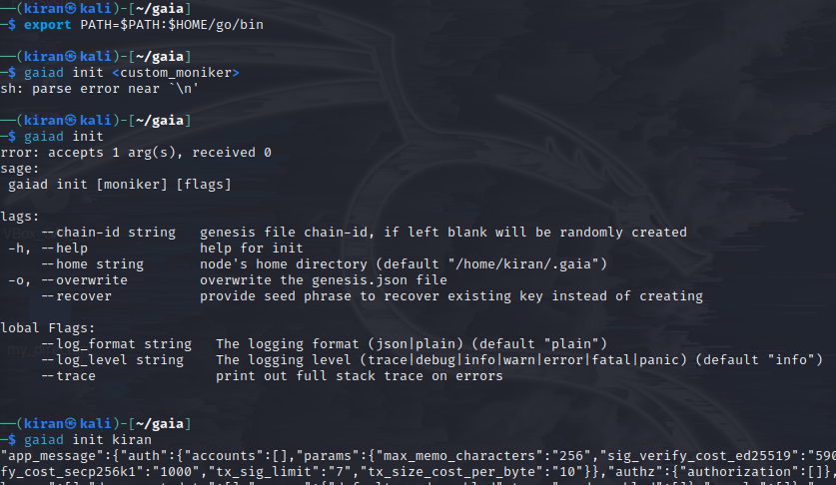

1. Prepare the genesis file.

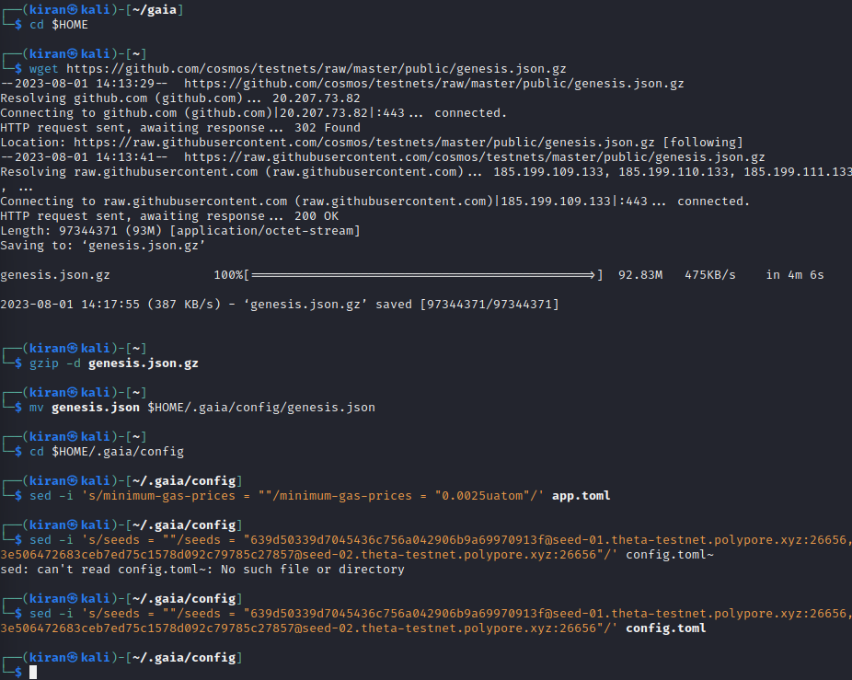

1. State Sync Setup:

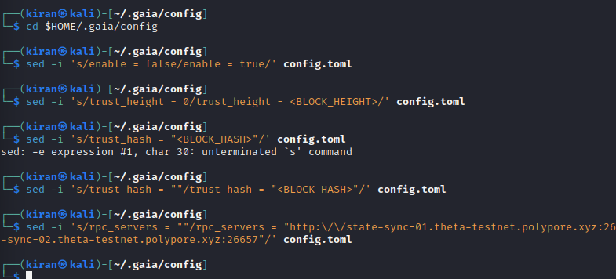

1. Cosmovisor setup:

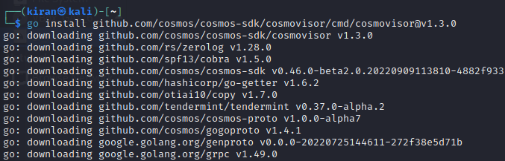

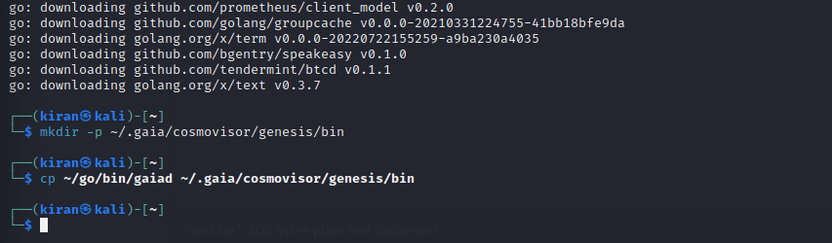

1. Create Service File:

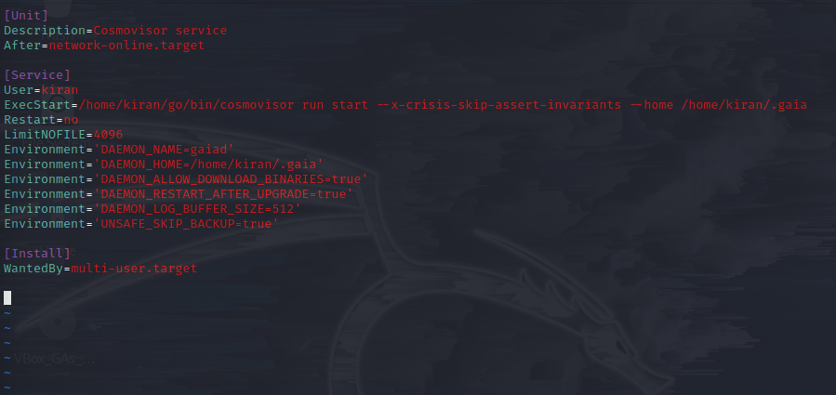

1. Setting up the keyring:

The keyring holds the private/public keypairs used to interact with a node.

Here, we have used the libsecret library as the backend.

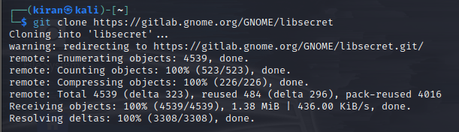

1. Start the service:

